Research Articles-Websites

Directions:
Minimum of three articles/websites about your topic that enhances your knowledge of WHY you are doing what you are doing.
Links of article/website posted on your website
Each link needs…
- One paragraph, written in your own words
- Minimum of five complete sentences

Linking Directions
In the textbox that you added to your page, use the title of the article or a very short description of the information.

Highlight your text and select the option that looks like two ovals interlocking.
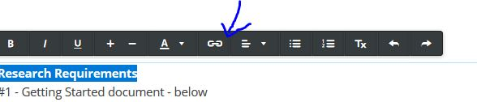

Copy and Paste the article/website address in your link to a Website URL

After you complete this, when you publish your page, you should be able to click on the link and it will go to the page you got your information.

Under this link, write your paragraph about the information you read about.

