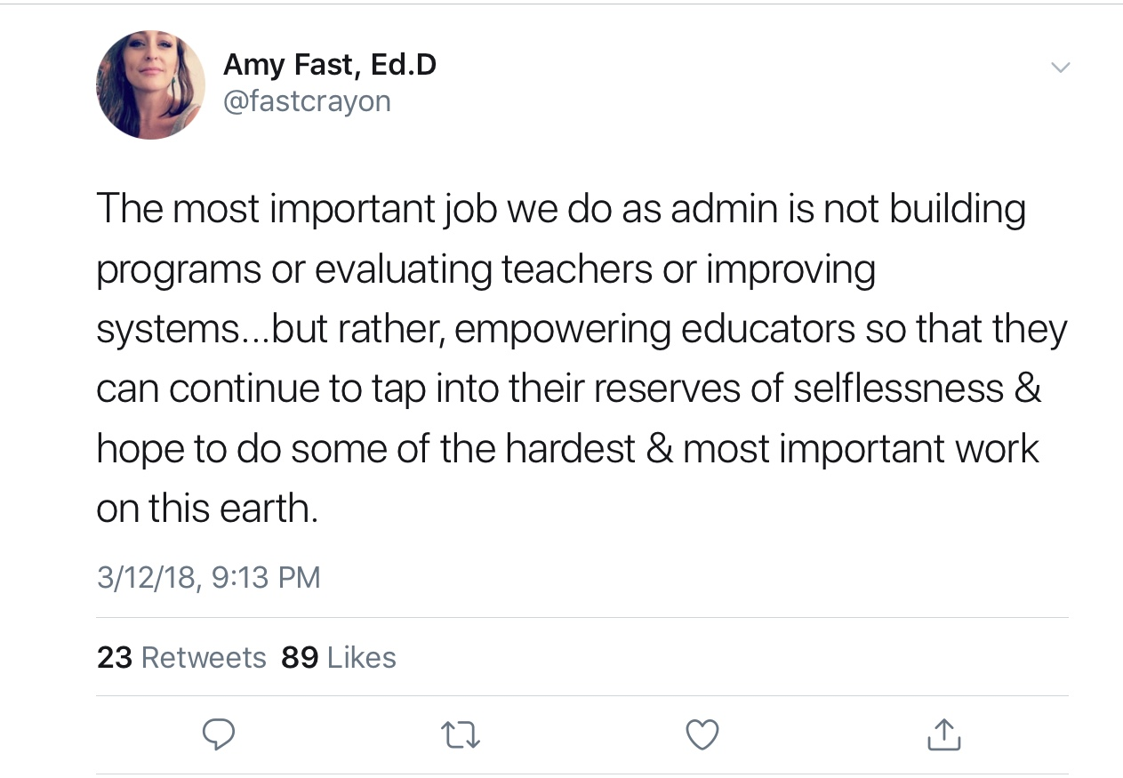
While I have been thinking about what to write about ethics and creating an ethical culture I come back to the thoughts of my personal learning network on Twitter. The above tweet was by Dr. Amy Fast, author of It’s the Mission, Not the Mandates and an assistant principal in Washington state. When thinking about the work that is taken on each and every day in a school building the titled “leadership,” being ethically responsible will allow the teachers and support staff in the building to do their work to their fullest potential.

As I continued to read on ethical leadership I came across the following from The Marshall Blog and the 7 Principles of an Ethical Leadership Culture.

Principles withstand the test of time. The following 7 Principles have been developed over the last forty years, and have been tested and embraced in a wide range of businesses on five continents—they represent the best of many cultures:
- Ownership: People take care of what they own; there is a commitment to others owning the direction of the organization, its work practices, and their jobs
- Alignment: Everyone is headed in the same direction; leadership inspires others, takes a strategic perspective, and engages everyone on the organization’s vision, mission, and strategy
- Full Responsibility: People are fully responsible for the success of organization and each other
- Self-Accountability: Rather than “asking for forgiveness”, people are self-accountable for, and own up to, their behavior as well as business results
- Mutual Respect: Everyone’s self-esteem matters, regardless of who they are; there is respect for diversity, and a focus on respectful behavior that builds high self-esteem in everyone, at every level of the organization
- Integrity: Leadership walks the talk and ensures that everyone else does
- Trust: There is a focus on being trust-worthy; fear is rejected as a way to motivate; there is transparency in business practices

Another member of my PLN is George Couros, in his blog post Moving From “Stealing” to “Remixing” With Credit, talks about the value of teaching using “terms like “remixing”, “altering” or “build on” (all with references) but never “stealing.” I believe as an administrator this type of work is not only ethical but needed to have relevancy for any site that is working to change a culture to be more ethical and student centered.

A strategy that I would implement would be asking teachers to come to a meeting with their idea of what attributes they believe our ethical culture should have and remix any and all ideas to meet our needs and do the deep learning to incorporate those standards to the best of our abilities.

I need to be an educator who leads ethically in order to empower other educators to model the same behavior while impacting our youth in such a powerful way each and every day!

